**May 5 Lab questions**

#1. WAP to swap the values of two variables by using a suitable user

defined function (say SWAP) for it.

Code:

#include <stdio.h>

void swap(int x_285, int y_285)

{

    int temp_285;

    temp_285=x_285;

    x_285=y_285;

    y_285=temp_285;

    printf("The values after swapping are a='%d' and b='%d'\n",x_285,y_285);

}

int main()

{

    int a_285,b_285;

    printf("Please give the value of your first number\n");

    scanf("%d",&a_285);

    printf("please provide the value of your second numebr\n");

    scanf("%d",&b_285);

    printf("===================\n");

    printf("The numbers before swapping are a='%d' and b='%d'\n",a_285,b_285);

    swap(a_285,b_285);

    return 0;

}

Output:

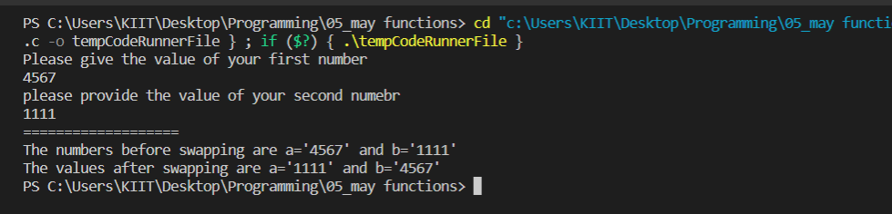

#2. WAP to find out n c r factor by using a user defined function for

factorial (say fact).

Code:

#include <stdio.h>

int fact(int f_285)

{

    int i_285,n_285;

    n_285=f_285;

    for(i_285=1;i_285<f_285;i_285++)

    {

        n_285=n_285*(f_285-i_285);

    }

    return n_285;

}

int main()

{

    int n_285,r_285,sub_285,a_285,b_285,c_285,ncr_285;

    printf("Please provide your n=\n");

    scanf("%d",&n_285);

    printf("provide your r=\n");

    scanf("%d",&r_285);

    sub_285= n_285-r_285;

    a_285=fact(n_285);

    b_285=fact(r_285);

    c_285=fact(sub_285);

    ncr_285=a_285/(c_285*b_285);

    printf("The computation of %d and %d is %d\n",n_285,r_285,ncr_285);

    return 0;

}

Output:

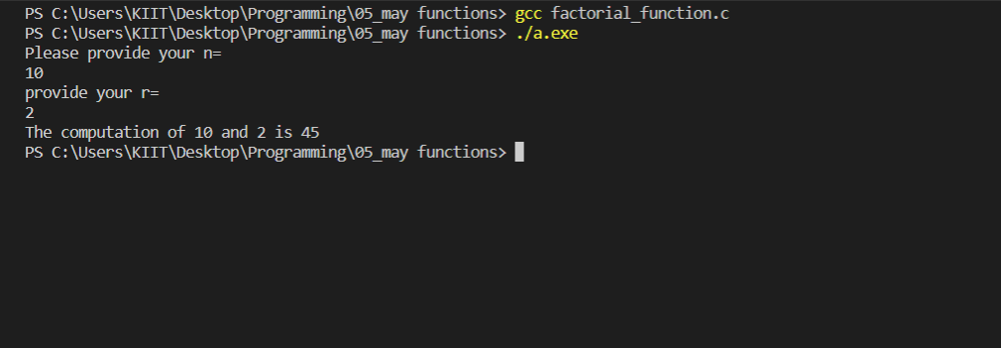

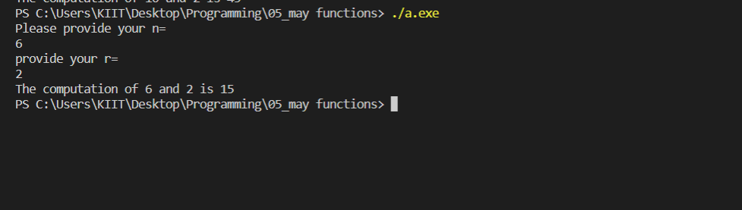

#3. WAP to test whether a number n is palindrome number or not.

Code:

#include<stdio.h>

int checkPalindrome(int number_285)

 {

  int temp_285, remainder_285, rev_285=0; temp_285 = number_285;

while( number_285!=0 )

   {

remainder_285 = number_285 % 10;

  rev_285 = rev_285*10 + remainder_285; number_285 /= 10;

 }

if ( rev_285 == temp_285 )

 return 0;

 else return 1;

  }

  int main()

 {

  int number_285;

  printf("Enter the number: ");

 scanf("%d", &number_285);

if(checkPalindrome(number_285) == 0)

  printf("%d is a palindrome number.\n",number_285);

  else printf("%d is not a palindrome number.\n",number_285);

 return 0;

 }

Output:

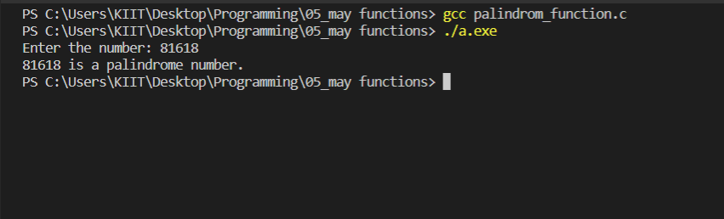

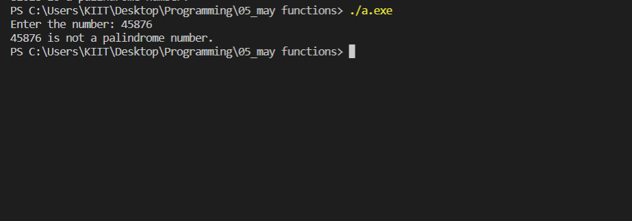

#4. WAP to calculate x^y x, y by writing a function (say POWER) for it.

Code:

#include <stdio.h>

int power(int x_285, int y_285)

{

    int res_285=x_285,i_285;

    for(i_285=1;i_285<y_285;i_285++)

    {

        res_285=res_285*x_285;

    }

    return res_285;

}

int main()

{

    int x_285,y_285,result_285;

    printf("Please provide the number;\n");

    scanf("%d",&x_285);

    printf("Please provide the exponent\n");

    scanf("%d",&y_285);

    result_285 = power(x_285,y_285);

    printf("The result is %d\n",result_285);

    return 0;

}

Output:

